[kali@Harini]$ vi dns.c

[kali@Harini ]$ cc dns.c

[kali@Harini]$ ./a.out

90.0.0.36

IP ADDRESS=90.0.0.36

HOST NAME=90.0.0.36

ADDRESS LENGTH =4

ADDRESS TYPE=2

LIST OF ADDRESS=90.0.0.36

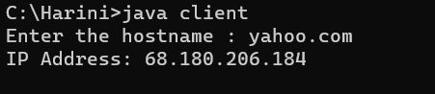

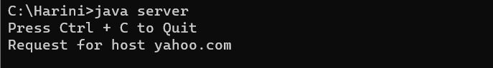

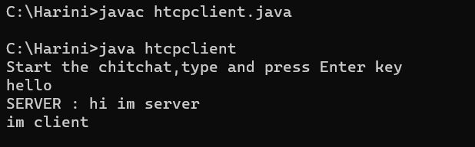

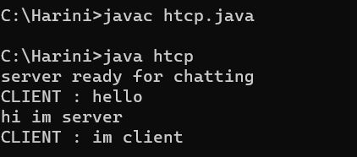

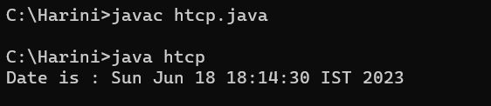

**SERVER:** C:\Harini>javac server.java

C:\Harini>java server

**SERVER:**

**C:\Harini>javac server.java**

**C:\Harini>java server**

**hjii**

**Server Says : hjii**

**Client Says : hello**

**Im fine**

**Server Says : Im fine**

**Client Says : HOW ARE YOU**

**CLIENT:**

C:\Harini>javac client.java

C:\Harini>java client

hello

Client Says :hello

Server says :hjii

HOW ARE YOU

Client Says :HOW ARE YOU

Server says :Im fine

***Client***

C:\Harini>javac htcpclient.java

C:\Harini>java htcpclient

Start

hello

SERVER : hi im server

im client

***Server***

C:\Harini>javac htcp.java

C:\Harini>java htcp

server ready for chatting

CLIENT : hello

hi im server

CLIENT : im client

ARP:

C:\Harini>javac arpc.java

C:\Harini>java arpc

Enter the Logical address(IP): 165.165.80.80

The Physical Address is:6A:08:AA:C2

